**Deep Learning Applications in Car Damage Detection**

Tanush Sharanarthi, Shreyas Iyer, Hsueh-Yao Lu, Xiaoyue Li

**The Applications of AI – Deep learning in the Automotive Supply Chain**

**Introduction**

Automotive machine learning can improve factory efficiency and the quality of its products. The robots and equipment used to build cars have sensors that send alerts about defective parts[1].

This can help manufacturers make repairs before they shut down assembly lines or cause damage. A study by Capgemini[2] found that smart technology could add $160 billion annually to the global automotive industry by 2023, as productivity increases[3].

Quality control in factories is also improving thanks to machine learning. The workers who take on this job are at risk of human error. However, machine learning can improve the process by collecting feedback and updating the system.

Audi uses cameras that can detect cracks in sheet metal that are not visible to the human eye. Software based on a sophisticated artificial intelligence neural network runs under this innovative machine learning program, which accurately detects the tiniest cracks in sheet metal parts and reliably marks their location[4].

General Motors uses sensors to monitor plant conditions4. For example, if a painted area is too hot or too cold, the paint will not cure, and the equipment may malfunction.

For quality control inspection work like checking the painted car bodies, human workers manually perform the inspection. However, this method is highly prone to errors and is very tedious. The chances of getting false positives are quite high even by using automated methods if factors such as lighting are not perfect or due to incorrect mounting of the product. By contrast, AI-enabled visual quality control can focus only on the defects by filtering out these issues. The AI system uses feedback to constantly learn to improve its analysis. Using these methods, AI-powered hardware can visually inspect and provide superior quality control on various products such as machined parts, painted car bodies, textured metal surfaces, and more.

Also, artificial intelligence-based machines can detect defects up to 90 percent more accurately than humans[5]. Valuable insights can be drawn from AI-based quality testing which can be used to analyze the root causes of the defects and enhance the prosecution processes. Productivity increases in the visual quality inspection by up to 50 percent are possible5.

Furthermore, an artificial intelligence-enabled damage recognition system is a set of deep learning algorithms that utilizes computer vision. Based on deep learning, the algorithms automatically detect a vehicle's body and analyze the extent of the damage. Parallel machine learning and analytical pipelines speed the analysis process up to seconds.

The solution speeds up the insurance claim, saving the company’s spending on human resources, defending from fraud (in 80% and more), and boosting the process of image data analysis in time. The system is used on sight and guides a user on actions to meet photo requirements. By deploying car damage recognition, businesses replace a human-operated time-consuming process of claims proceeding and approval with machine learning algorithms and analytical systems[6].

A machine learning system was developed to reduce the time and efforts spent on human inspection and ensures smart decision-making for the following businesses:

1. Insurance Company: It can help to prevent fraud (in 80 percent of cases) and speeds up the underwriting process.

2. Car repair services: To create a collaborative environment, that brings transparency to the repair process and costs.

**Deep Learning in Defects Detections -** Deep learning is a subset of machine learning in artificial intelligence that uses mathematical models to map the input to the output. These models can extract the relevant information or patterns from the data, and this enables them to form a relationship between the input and the output. This process of machine learning is called training[7].

Deep learning models use [artificial neural networks](https://www.v7labs.com/blog/neural-network-architectures-guide) or simply neural networks to extract information. Neural networks are the crux of deep learning models, and they are designed in such a way that they resemble actual neurons in the human brain7.

These neural networks are made up of simple mathematical models that can be stacked on top of each other and arranged in the form of layers, giving them a sense of depth, hence the term Deep Learning7.

The main characteristic of Deep Learning that distinguishes it from other machine learning models is that deep learning models can *process unstructured data*. Unstructured data includes text, image, and video data. However, this has its drawbacks as well since to run deep learning models, we require high computation power, and it is more expensive[8].

There are different types of neural networks such as Convolutional Neural Networks (CNNs), Recurrent Neural Networks (RNNs), and Long Short Term Memory (LSTMs). In our model to detect the defects in automobiles, we use a CNN to classify the images.

The components of a neural network are as follows:

Fig. 1. Structure of a neuron in a neural network

Here, x1, x2, …x m are the inputs and multiplied by their respective weights Wk1, Wk2,...W km, and then the overall weighted inputs are summed with a bias. The bias adds an element of unpredictability to our model, which helps it generalize and gives our model the flexibility to adapt to different unseen inputs when using testing data. This weighted sum is then pushed through a mathematical function known as an activation function. The activation function does some transformation on the nodes and then passes the result to the output so that it can be fed to the subsequent layer to be outputted as the final result.

**Layers in Action** – A neural network can comprise a large number of layers. These layers are of 3 types - an input layer, an output layer, and hidden layers.

The data is fed into the input layer and each node in the input layer assimilates the data and passes it to the next layers which are the hidden layers. The hidden layers extract features from the input layer and transform them using a linear function. Hidden layers are called so because the parameters (weights and bias) in the nodes are not known. Each output from these layers is different in that the *layers add random parameters* to transform the data[9].

The output from these hidden layers is then passed on to the final layer which is called the output layer. The output layer yields a result that can be used for a variety of tasks such as prediction or classification based on the requirement. In our model, we perform a classification since we want the images of the vehicles to be classified as either damaged or whole cars. This process is called forward propagation.

There is another process called *backward propagation* in which an algorithm such as gradient descent is used to calculate the errors by taking the difference between the predicted output and the original output.

By performing both forward propagation and backpropagation the neural network can achieve high efficiency and accuracy, thereby reducing the error in a particular task. With each iteration, the algorithm becomes gradually more accurate. Therefore, we train the model on multiple epochs.

Fig. 2. Layers in a neural network

**VGG-16 Convolutional Neural Network model in Car Damage Detection**

In our deep learning model, we are using the VGG-16 (Visual Geometry Group ) Convolutional Neural Network Model for detecting any damages in cars. This model was originally developed by the Visual Geometry Group at the ILSVR 16 (ImageNet Large Scale Visual Recognition) competition in 2014[10]. It has convolutional layers of 3x3 filter and stride 1 with padding and maxpool layers of 2x2 filter and a stride of 2. It focuses on these layers rather than having a large count of hyperparameters. The VGG-16 model contains an arrangement of alternating convolution and maxpool layers throughout the network. In the end, it consists of 2 Fully Connected layers with a softmax at the output. The model consists of 16 layers with weights associated with them.5

The network below is a representation of the VGG-16 model we used to build our car damage prediction system.

Fig. 3. Representation of the VGG-16 model

As we can see there are a total of approximately 18 million parameters. At the input layer images of dimension, 150x150x3 are used. Here 150x150 is the size of the image and the 3 is used to represent the RGB color value.

The different layers have specific operations which they will perform on the data. Below we have explained the use of each layer in the VGG-16 model.

**Convolutional Layer**: A convolution is the application of a filter to an input that gives us an activation. Repeated application of the same filter to the input will result in a map of activations which is called a feature map. The feature map will indicate the locations and strength of a detected feature in input, such as an image[11].

Fig. 4. Representation of convolutional layer.

**Maxpool Layer**: In the Max pooling layers we select the maximum element from the region of the feature map that is covered by the filter. Hence, the output after a max pool layer is a feature map that contains the most important features of the previous feature map11.

Fig. 5. Visual representation of maxpooling layer.

**Dense Layer**: The dense layer in a deep learning model is a neural network that is deeply connected. This means every neuron in the dense layer is connected to all the neurons in the previous layer and receives inputs from them. Matrix-vector multiplication is performed in the dense layer and the values are the parameters that are trained and updated through backpropagation. The output from this layer is an n-dimensional vector. Hence, these layers are used to change the dimensions of a vector and also perform operations such as scaling, rotating, and translation on the vector[12].

.

**Flatten Layer**: Flattening is used to convert data into a 1-dimensional array for inputting it to the next layer. We flatten the output of the convolutional layers to create a single long feature vector. This is then connected to a fully connected layer that helps in classification12.

.

**Dropout Layer**: The dropout layer will help reduce overfitting by dropping neurons in subsequent layers with particular probabilities. This is a form of regularization that we are using in our model[13].

.

**Convolutional Neural Network Feature Map Visualization**

Given below are feature map visualization outputs from two of the convolutional layers. We can see here that here in some of the images the car as a whole is highlighted and in some places the background. In most places, we see that tiny features are being highlighted such as the car’s door handles, wheels, and bumpers along with any of the damages. This is ideally what we are looking for and as the images are passed through more and more layers, the features we are looking for become more evident. While it is not easy here to visualize the features through this map just like in any other Convolutional Neural Network (CNN) we get a rough picture of how the model is working underneath[14].

Fig. 6. Feature map visualization of 1st layer.

Fig. 7. Feature map visualization of 3rd layer.

**Training Damage Detection Model Using CNN**

Now, we will use the deep learning methods we just talked about to train a model and show the performance of our model in detecting damaged cars. The data set we found was from Kaggle[15], which is an online data science community platform. It includes a set of training data and a set of validation data.

There are a total of 1840 car images in the training data where half of them are damaged cars, and half of them are non-damaged cars, and the validation data has 460 car images where half of them are damaged cars, and half of them are non-damaged cars. The picture below is a brief showcase of the images that are included in the data sets.

Given below is an example of a few images from the dataset that we have used for training our model. The first row contains cars that are damaged, and the second row contains a few images of cars that are whole and not damaged.

[16]

As explained above, we have used the VGG-16 Convolutional Neural Network to train our data and build the classifier for predicting if cars are damaged or not.

**Testing Accuracy**

We use 6 epochs to train our model, and the validation accuracy and the validation loss for the final epoch are 88.67 percent and 30.07 percent respectively. The accuracy and losses for each epoch are listed in the pictures below:

Fig. 8. Training epochs

Fig. 10. Training and validation accuracy curves.

Fig. 11. Training and validation loss curves.

We can see that the validation accuracy lies around 90 percent, which is a good indication of the reliability of our model. Below are a few examples of the images detected:

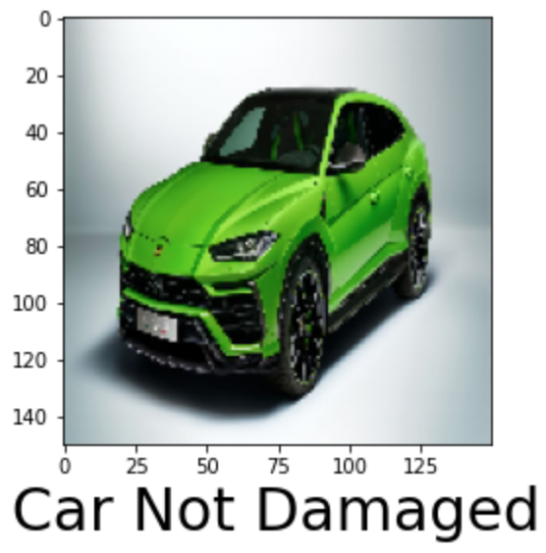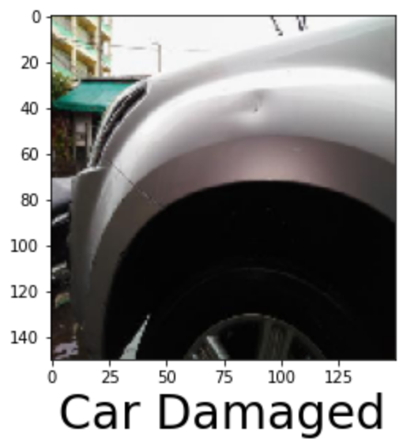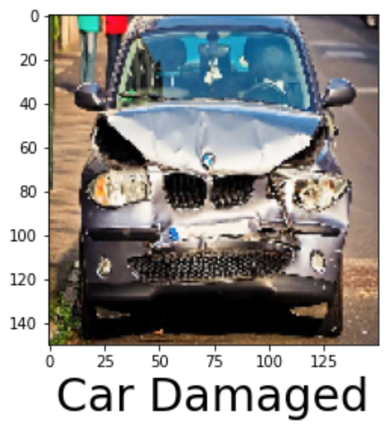[17]

Even small damages to the car would be detected, and some noise in the background would not affect the prediction. This indicates that our model is capable of making judgments like humans.

**Drawbacks**

Even though a neural network is very powerful and can save a lot of time and resources for auto companies, there are a few limitations and drawbacks to it.

First, the neural network process is a black box process. In other words, we do not know the process or reasons behind the output we are getting. This makes the model less convincing since we are not able to explain to the stakeholders why we are getting the results. Also, it makes improving the model harder since we would not know what part of the model is wrong if it does not give us a satisfactory result[18].

Second, the time and resources spent on the neural network process are huge. The company will need strong computational power computers, an enormous data set, and enough time to run the results. These conditions will be hard for smaller companies to achieve, and without them, a neural network model would not perform well, and it may even be worse than the traditional machine learning model.

Lastly, neural network models have problems with overfitting, vanishing gradient, and local minima problems. All these problems can make the model less accurate and less reliable and require some other methods to solve.

**Other AI Usage**

Other than car damage detection, artificial intelligence can be used in many other areas in the automotive industry. For example, AI can be used in designing and developing new cars. By implementing AI, car manufacturers can develop a better design and eliminate possible errors in the first place. Volkswagen is already using the Generative Design method which implements AI when they manufacture cars[19]. Also, AI can be used in predictive maintenance. Automakers can find out and eliminate malfunctioning parts beforehand instead of solving the problems after problems arise. It makes the manufacturing process go much more smoothly and saves unnecessary losses.

**CONCLUSION**

This project proposed an efficient AI-based model for the Automotive Supply Chain that helps in detecting damages in Cars using the VGG-16 Convolutional Neural Network model. Unlike the traditional manual processes of quality inspection used in this industry, this method will help automate the process making the entire process more efficient. The results showed that the model was able to accurately detect any damages in cars irrespective of the automobile’s type, color, and dimensions. It was observed that even the automobiles with minor scratches and dents were classified as damaged making this model highly reliable. There are many places this model can be used across the automotive supply chain and the future scope is to determine how to integrate this technology into other industries such as insurance companies and car repair services.

**References**

Cprime Studios, “What Are Machine Learning Use Cases in the Automotive Industry?”, Dec 17. 2021, <https://cprimestudios.com/blog/what-are-machine-learning-use-cases-automotive-industry>

Capgemini, “New research from Capgemini shows the automotive industry could gain $160 billion through smart factory adoption by 2023 onwards”, Apr 30. 2018, <https://www.capgemini.com/pl-pl/news/new-research-from-capgemini-shows-the-automotive-industry-could-gain-160-billion-through-smart-factory-adoption-by-2023-onwards/>

Donges N, “4 reasons why deep learning and neural networks aren't always the right choice”, Jul 24. 2019, <https://builtin.com/data-science/disadvantages-neural-networks>

Marko Petzold, “Use Cases: Utilising IOT & AI in Automotive.” *Record Evolution*, Mar 31. 2021, <https://www.record-evolution.de/en/blog/use-cases-utilising-iot-and-ai-in-automotive/>

Tanmay Thaker, “VGG 16 Easiest Explanation” *Medium*, Aug 8. 2021, <https://medium.com/nerd-for-tech/vgg-16-easiest-explanation-12453b599526>

Pragati Baheti, “A Gentle Introduction to Deep Learning - the eli5 Way.” *V7*, Mar 8. 2022, <https://www.v7labs.com/blog/deep-learning-guide>

Krishna, Dhruva. “The Components of a Neural Network.” *Medium, Towards Data Science*, Jan 5. 2021, <https://towardsdatascience.com/the-components-of-a-neural-network-af6244493b5b>

Kajal Singh, SB Goyal, Pradeep Bedi, “The Role of Artificial Intelligence and Machine Learning in Supply Chain Management and Its Task Model.” *IEEE Xplore*, Jan 18. 2021

<https://ieeexplore.ieee.org/document/9315890>

Mejia, Niccolo, “AI in the Automotive Industry - an Analysis of the Space.” *Emerj Artificial Intelligence Research, Emerj*, Feb 12. 2019, [https://emerj.com/ai-sector-overviews/ai-in-the-automotive-industry-an-analysis-of-the-space](https://emerj.com/ai-sector-overviews/ai-in-the-automotive-industry-an-analysis-of-the-space/)

Halima Bousqaoui, Said Achchab, Kawtar Tikito, “Machine Learning Applications in Supply Chains: An Emphasis on Neural Network Applications.” *IEEE Xplore*, Feb 08. 2018,

<https://ieeexplore.ieee.org/document/8284722>

Andre Luckow, Ken Kennedy, Marcin Ziolkowski, Emil Djerekarov, Matthew Cook, Edward Duffy, Michael Schleiss, Bennie Vorster, Edwin Weill, Ankit Kulshrestha, and Melissa C Smith “Artificial Intelligence and Deep Learning Applications for Automotive Manufacturing.” *IEEE Xplore*, Jan 24. 2019,

<https://ieeexplore.ieee.org/document/8622357>

Qualitas Technologies, “Machine Vision in Defect Detection Activities Using AI and 3D”, May 11, 2020, <https://qualitastech.com/machine-vision-in-defect-detection-activities-using-ai-and-3d/>

Khandelwal, Renu, “Convolutional Neural Network: Feature Map and Filter Visualization.” *Medium, Towards Data Science*, May 18. 2020, <https://towardsdatascience.com/convolutional-neural-network-feature-map-and-filter-visualization-f75012a5a49c>

Govinda Dumane, “Introduction to Convolutional Neural Networks using Tensorflow”, *Medium*, *Towards Data Science*, Mar 2. 2022, <https://towardsdatascience.com/introduction-to-convolutional-neural-network-cnn-de73f69c5b83>

P. Dileep, D. Das, and P. K. Bora, "Dense Layer Dropout Based CNN Architecture for Automatic Modulation Classification," *2020 National Conference on Communications (NCC)*, Apr 06. 2020, <https://ieeexplore.ieee.org/document/9055989>

1. “Use Cases: Utilising IOT & AI in Automotive.” *Record Evolution*, Marko Petzold, Mar. 31, 2021
2. “New research from Capgemini shows the automotive industry could gain $160 billion through smart factory adoption by 2023 onwards” *Capgemini*, Apr. 30, 2018
3. “Ai in the Automotive Industry - an Analysis of the Space.” *Emerj Artificial Intelligence Research*, Emerj, Mejia, Niccolo, Feb. 12, 2019
4. “What Are Machine Learning Use Cases in the Automotive Industry?” *Cprime Studios*, Dec. 17, 2021
5. “The Components of a Neural Network.”, Krishna, Dhruva, Aug. 5, 2021
6. “Machine Vision in Defect Detection Activities Using AI and 3D.” *Qualitas Technologies*, May 11, 2020
7. “A Gentle Introduction to Deep Learning - the eli5 Way.” *V7*, Pragati Baheti, Mar. 8 2022
8. “4 reasons why deep learning and neural networks aren't always the right choice”, Donges, N, Mar. 18 2021
9. “The Components of a Neural Network.”, Krishna, Dhruva, Aug. 5, 2021
10. “VGG-16 Easiest Explanation”, Tanmay Thaker, Aug. 8, 2021
11. “Introduction to Convolutional Neural Network using Tensorflow”, Govinda Dumane, Mar. 2, 2020
12. “Introduction to Convolutional Neural Network using Tensorflow”, Govinda Dumane, Mar. 2, 2020
13. “Dense Layer Dropout Based CNN Architecture for Automatic Modulation Classification”, P Dileep, Dibyaiyoti Das, Prabin Kumar Bora, Apr. 6, 2020
14. “Convolutional Neural Network: Feature Map and Filter Visualization.”, Khandelwal, Renu, May 18, 2020
15. “Car Damage Detection,” Kaggle, July 27, Anuj Shah, 2019
16. Anuj Shah, “Car Damage Detection,” Kaggle, July 27, 2019
17. Anuj Shah, “Car Damage Detection,” Kaggle, July 27, 2019
18. “4 reasons why deep learning and neural networks aren't always the right choice”, Donges, N, Mar. 18, 2021
19. “What Are Machine Learning Use Cases in the Automotive Industry?,” Cprime Studios, Dec. 17, 2021